Cassandra DB

Cassandra is a NoSQL (Not Only SQL) so its an extended version of SQL but in a distrubuted way.
It is recommended to go through MySQL once to help go ahead surf smoothly with Cassandra.

Popularity
Cassandra was created by Facebook – now why facebook – coz there is lot of data coming in to facebook like media, messages, profile data, new accounts every single minute at a very high speed, just imagine you sharing a post or a meme (giggles- I do that a lot) and it appears on you wall and others wall in a matter of split second – in that matter of split second (it reads the post writes to you wall, writes to others feed in your name as think of so many of them sharing from your friends list. It all happens so fast and it is the need of the hour as well. With the infrastructures/servers getting so powerful it need to be coupled with database that helps do the read write with that amount of speed, and cassandra DB (NoSQL) does it so well hence the popularity.

Important Points of Cassandra
- Cassandra is a column-oriented database
as Cassandra is a distrubuted DB it is important to search using a Tag/clue(popularly called the primary key) or the system might go searching in all directions and hence reduce performance. So PK is associated with coulmn like NAME or a EmpId which can be set at the time of creating the TABLE.
- Cassandra is Scallable, consistent, and fault tollerant
As large amount of data comes in Cassandra its is import it is able to make writes at a greater speed, and consistent by means of following all the contraints and data integrity rules are followed. Fault Tolerance is an important and highly useful feature of Cassandra/nosql db as it distributed and a single failure does not mean loss of data. As companies their data as it is critical, and cassandra maintains data across its all nodes and hence single point failure wont affect the bussiness data as same data is available across all nodes.

What is Keyspace? -
Keyspace is like the Aadhar Card – it has all the details like the names of columns created/used, user defined datatypes, strategy used in keyspace( ), the replication factor (to keep replications of data across which nodes)

Strategy used in keyspace – 2types
- Simple strategy – used when there is only one data center (datacenter is a collection of nodes), consider 4 points of a Square as nodes, the connection of these 4 points is datacenter as it is a collection of the 4 nodes, so the data is stored in all the nodes but one node has the actual data and the replication is done by providing the replication to the next node and thus replication is done in a clockwise direction.
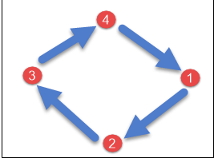
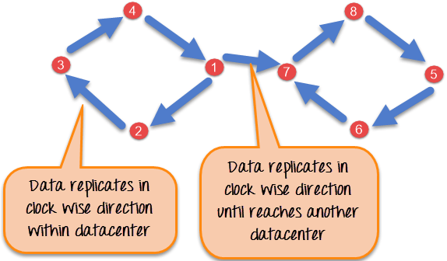
- Network Strategy – where there are more than one data center or more than one square so data is replicated in one datacenter in clockwise direction and then passed on to the next datacenter or next square.

CREATE KEYSPACE

Syntax -

CREATE KEYSPACE_NAME <identifier> WITH <properties>

Generic Example -
Create keyspace KeyspaceName with replicaton={'class':strategy name,
'replication_factor': No of replications }

Example -
CREATE KEYSPACE Employee_records
WITH replication = {'class':'SimpleStrategy', 'replication_factor' : 3};

ALTER KEYSPACE

Syntax -

ALTER KEYSPACE_NAM <identifier> WITH <properties>

Generic Example -
Alter keyspace KeyspaceName with replicaton={'class':strategy name,
'replication_factor': No of replications }

Example -
Alter KEYSPACE Employee_records
WITH replication = {'class':'NetworkStrategy', 'replication_factor' : 3};

Points to Note -
1. we cannot alter the keyspace_name
2.we can alter the replication's – strategy and replication_factor in short the Properties of the
keyspace(highlighted)

Drop keyspace -
DROP keyspace keyspace_name

CREATE table with Primary Key -

CREATE TABLE tablename(
column1 name datatype PRIMARYKEY,
column2 name data type,
column3 name data type.
)

Example-
CREATE TABLE student(
student_id int PRIMARY KEY,
student_name text,
student_city text,
student_fees varint,
student_phone varint );

There are 2 types of PK-
- Single PRIMARY KEY -
Primary Key(Column1)

- Compound PK
Primary Key(Column1, Column2,...)

ALTER TABLE -

ADDing a column
Syntax -
ALTER TABLE table_name ADD column_name data_type ;

Example -
ALTER TABLE student ADD student_address text ;

DROPing a column
Syntax -
ALTER TABLE table_name DROP column_name ;

Example -
ALTER TABLE student DROP student_address ;

to drop multiple columns -
ALTER TABLE student DROP(student_address, student_city) ;

DROP Table

DROP TABLE <tablename>

DROP TABLE student;

TRUNCATE table – to delete all rows in a table

TRUNCATE <tablename>

TRUNCATE student;

Cassandra Create Index
CREATE INDEX command is used to create an index on the column specified by the user. If the data already exists for the column which you choose to index, Cassandra creates indexes on the data during the 'create index' statement execution.

A primarykey is always indexed so cannot index PK,
Without indexing on the column, Cassandra can't filter that column unless it is a primary key.

Syntax -
CREATE INDEX <identifier> ON table_name(column_name)

CREATE INDEX name ON student (student_name)

